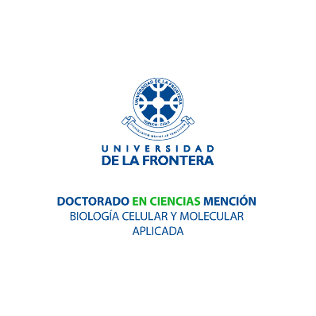

APPLICATION FORM FOR SPEAKERS TO THE “I INTERNATIONAL WORKSHOP ON APPLIED CELLULAR AND MOLECULAR BIOLOGY”

Please read the INSTRUCTIONS below before filling up the form:

This form comprises an essential part of the selection process for the panelist section at “I INTERNATIONAL WORKSHOP ON APPLIED CELLULAR AND MOLECULAR BIOLOGY”

You are requested to fill all required details.

After filling out the form you must change the file name and replace "name" and "last name" with your personal information.

- Poster title:

- Research area of the work (Biotechnology of Animal and human reproduction, Biotechnology of Bioresources, or Cellular and Molecular Biology of Priority Diseases):

- Author(s) and affiliations (institution’s name):

Name | Institution

- Name of corresponding author:

- First author and corresponding author contact information:

E-mail:
Phone number:
Full affiliation:

E-mail:
Phone number:
Full affiliation:

- ABSTRACT (300 word max)

